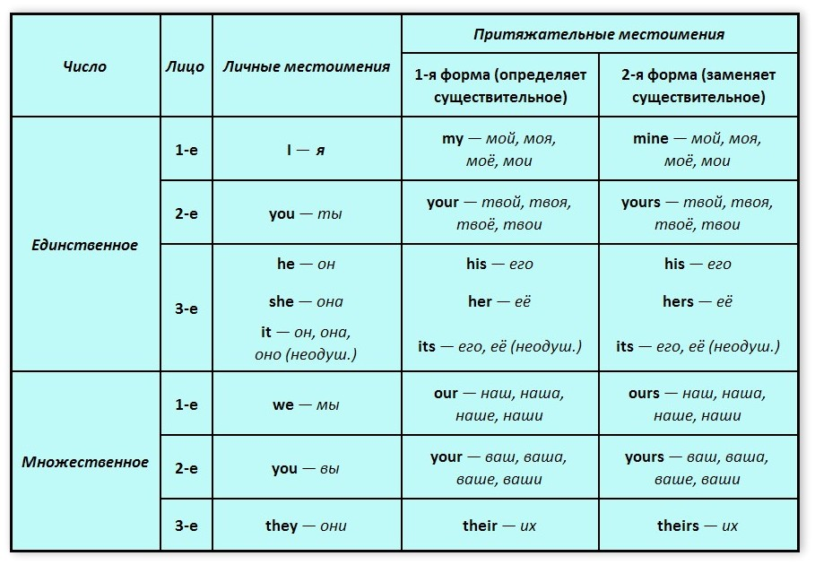

***Важно:***

1. ***Притяжательные местоимения (прилагательные) my, your, his, her, its, our, their, всегда требуют после себя существительное!! какая мама?( моя мама) my mom, какая машина? его машина (his car). His car is new. My mom is pretty.***
2. ***Чтобы сказать мое, твое, его, ее, их, наше, ваше и т.д. употребляется абсолютная форма притяжательного местоимения.***

***mine, yours, ours, his, hers****and****theirs****its - употребляются отдельно без существительного.*

*Example: Is it your bag ?Yes, it’s mine. (моя).We can’t say yes it’s my.*

*This is my book. Where is yours? ~~Not this is mine book.Where is your?~~*

*Мы редко употребляем форму its.*

***Complete the following sentences using the appropriate form of the possessive.***

1. This is my car. Where is ……………………? (your / yours)

2. …………………. car (my / mine) is quite fast. What about …………………. (your / yours)?

3. This is …………………. ticket (my / mine). Could you show me ………………… .. (your / yours)?

4. My hair is black. …………………. (her / hers) is gray.

5. …………………. (our / ours) daughter is prettier than …………………. (their / theirs)

6. ………………… (her / hers) new car is faster than ………………….. (my / mine**)**

1. We have a big garden … garden is young.
2. The book is new … contents is rather interesting.
3. She is a nice girl. What’s … name?
4. I’m Kathy Brown … family is large.
5. He has a lot of friends … friends are also students.
6. The Smirnovs have a car … car is expensive.
7. You are doing well … marks are always good.
8. We have a cat … character is kind.

***Упражнение 5.*** Выберите из подчёркнутых слов правильные притяжательные местоимения

1. Is this yours / your daughter?
2. It's theirs / their problem, not our/ours.
3. It's a good idea of your / yours to go to the bar tonight.
4. Are these her / hers shoes?
5. We're going swimming with some friends of our/ours.
6. Is it yours / your article about spiders? -No, it's not my / mine.
7. We know their / theirs address but they don't know our / ours.
8. That's not my / mine wallet. Mine / my is black.
9. His cottage is bigger than her / hers but her / hers is nicer.
10. My / mine parents live in Vitebsk region, and your / yours?

Tim: Whose CD is that?

Jenny: The Britney Spears CD? It's  (1) _______ . It's (2) _______ favourite CD.

Tim: It's (3) _________ too. Is this Kylie Minogue CD (4) ________ too?

Jenny: No, it's (5) ________ sister’s. And those on the table are (6) ________ too.

Tim: There's a Beatles CD on the table. Does she like The Beatles?

Jenny: No, she doesn't. But (7) _____ parents love them. All the Beatles CDs are (8) ______.

Tim: Can I borrow this one, or is it (9) _________ sister's?

Jenny No, it isn't (10) _________. I'll have to ask (11) _____ brother. That CD is (12) _______